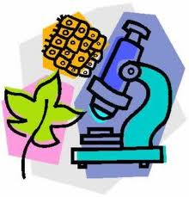
AP Biology Course Outline – 1st Semester
Week 1 – September 5 – September 9
MONDAY - No school Labor Day
TUESDAY - Introduction to AP Biology, expectations, grading, etc. Collect Summer Assignment Part II (Chapter 51-55 questions)
WEDNESDAY – Diagnostic Test – What do you remember? AP Biology Pretest; Pass out class overview packet and AP Biology Vocabulary list.
THURSDAY - Students select random lab table assignments; Vocabulary review activity. Each students will select random ecology vocab words and work withing groups to use words in connected meaningful sentences and then use them to write paragraphs to explain an ecology topic.
FRIDAY – Complete vocabulary assignment by using a minimum of 10 selected words to build an ecology based concept map. Summer assignment “Mystery Plants” due.

Week 2 - September 12 – September 16
MONDAY - Presentation of concept maps; Part III of Summer Assignment “What do Animals Do?”
TUESDAY - Introduce Chi Square analysis as statistical tool in biology; M&M Chi Square Lab ; Go over Standard Deviation and Standard Error.
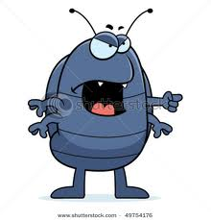

WEDNESDAY - Hand out AP Lab 11 Animal Behavior; Lab groups pick substances to test pill bugs preferences.
Go over Animal Behavior powerpoint.

THURSDAY - Students perform Animal Behavior lab.

FRIDAY - Complete behavior lab. Begin Ecology lecture: Factors affecting distribution of species

*********************************************************************************************
Week 3 – September 19 - 23
MONDAY - Continue Unit 1 lecture: Population biology and Energy Flow in Ecosystems “Rule of Ten” Hand out AP Lab 12 “Dissolved Oxygen” Lab bench quiz due on Wednesday, September 21
TUESDAY– Continue Unit 1 lecture: Energy flow in Community Interactions; Discuss AP Lab 12: “Dissolved Oxygen” Demonstrate Winkler Method used in lab and how to do titrations. Homework: pre-lab questions
WEDNESDAY – AP Lab 12 Set up Part 1; Reading of bottles may require more than I hour, expect to stay after school on Wednesday, if necessary to complete titrations.
THURSDAY - - AP Lab 12 Part II and Part III, (extra time may required to complete Part II). AP Lab 12 will require a formal write up. Formal lab report will be due on Thursday, September 29. ; Homework: Review questions for Unit 1 test. Suggested: view Bozemanbiology videos on Ecology for review
FRIDAY - Half-day; No AM classes

Week 4 - September 26 – September 30
MONDAY - Continue Unit 1 lecture: Human impacts on the environment; explain formal lab report
TUESDAY – UNIT 1 TEST – ANIMAL BEHAVIOR AND ECOLOGY (CHAPTERS 51,52,53,54,55,56) - TEST WILL FOLLOW AP FORMAT WITH 20 - 25 MULTIPLE CHOICE, 2 GRID IN MATH PROBLEMS, 2 – 3 SHORT ANSWER AND 1 LONG FREE-RESPONSE.

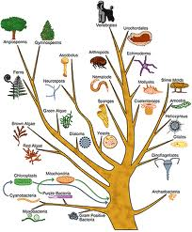
WEDNESDAY - Begin Evolution Unit: Chapter 22 reading guide due at beginning of hour. Lecture on Darwin and his theory.
THURSDAY - Formal lab report AP Lab 12 Dissolved Oxygen due at beginning of hour; Chapter 23 reading guide due at beginning of hour. Lecture Chapter 23, Population Biology. Review basic genetics terminology : homozygous, heterozygous, dominant, recessive, simple punnett squares.
FRIDAY - Chapter 23 reading guide due at the beginning of the hour. Hardy-Weinberg equation and practice problems. Pre-lab questions for Lab 8: “ Population Genetics”

Week 5 - October 3 – October 7
MONDAY – AP Lab 8 Population Genetics. Lab due on Thursday, October 6. Hand out “Mathematical Modeling – Hardy-Weinberg” Homework: Pre-lab questions. Look at Bozembiology video “Population Modeling”
TUESDAY - - Computer Lab: AP Investigative Lab: “Mathematical Modeling – Hardy-Weinberg” Post-lab questions due Monday, October 10.
WEDNESDAY - Computer Lab: Complete Mathematical Modeling, then go to ”Evolution” http://ats.doit.wisc.edu/biology/lessons.htm and proceed through program
THURSDAY - Chapter 24 reading guide due at beginning of hour. Lecture Chapter 24 Origins of Species.
FRIDAY - - Chapter 25 reading guide due at beginning of hour. Lecture Chapter 25, Origins of Life.

Week 6 - October 10 – October 14
MONDAY - Activity: Create concept map utilizing vocabulary words relating to Origins or Life
TUESDAY - Complete Concept map and present to class for peer review.
WEDNESDAY - Chapter 26 reading guide due at beginning of hour; Lecture on phylogeny and classification

THURSDAY - – Activity: “Cananimalicules”
FRIDAY - Continue activity: “ Cananimalicules
*********************************************************************************************

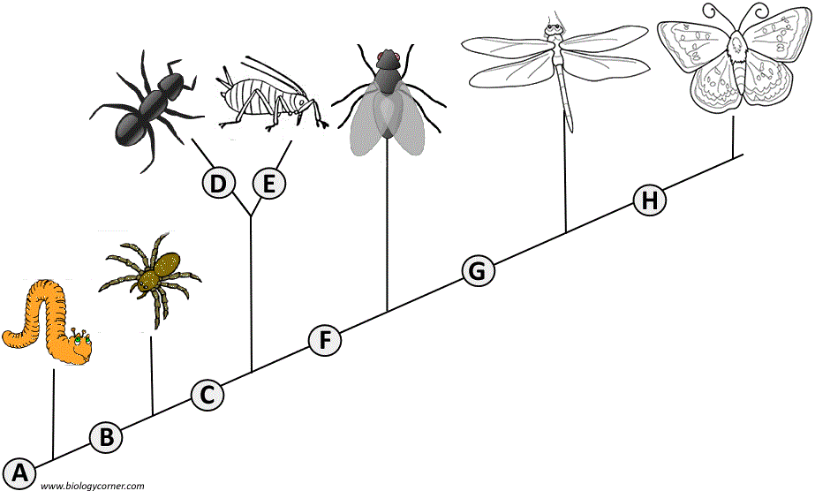
WEEK 7 - October 17 – October 21

MONDAY - Activity on developing cladograms – work in groups, due at end of hour. Handout AP Investigative Lab 3: Comparing DNA sequences to understand evolutionary relationships using BLAST (bioinformatics). Homework: Answer pre-lab questions, due, Tuesday; view Bozemanbiology video on youtube “Comparing DNA sequences”
TUESDAY – Computer lab: Blast Lab
WEDNESDAY - Complete Blast lab; Post-lab questions due Friday, October 17; Hand out list essay questions for Evolution Test.
THURSDAY - UNIT 2 EVOLUTION TEST (CHAPTERS 22,23,24,25, 26) 20 – 25 MULTIPLE CHOICE QUESTIONS, 2 GRID-IN MATH PROBLEMS, 2 SHORT ANSWERS AND ONE LONG FREE RESPONSE QUESTION.
FRIDAY - Chapter 27 reading guide due at the beginning of the hour; Six Kingdoms of Life; Lecture on Bacteria and Archaea

Week 8 – October 24 – October 28
MONDAY – Lecture: Evolution of the plant kingdom
TUESDAY - Lecture: Evolution of the animal kingdom; brief overview of protest and fungi

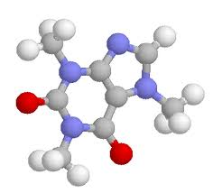
WEDNESDAY - Unit 4, Chemistry. Review of basic chemistry (Chapter 2 on your own). Look at review powerpoint;/ Chapter 3 reading guide due at the beginning of the hour. Lecture: Chapter 3: Properties of water
THURSDAY - Lab: Properties of Water

FRIDAY - Half-day; PM classes only

END OF FIRST CARDMARKING

SECOND CARDMARKING BEGINS
Happy Halloween!

Week 1 – October 31 – November 4
MONDAY - Chapter 4 reading guide due at the beginning of the hour. Chapter 5 reading guide will be due on Friday, November 4. Lecture on Chapter 4 and 5.1: Carbon chemistry and macromolecules.

TUESDAY – Lecture on Carbohydrates and Lipids – Chapter 5.2 and 5.3
WEDNESDAY - Modeling carbs and lipids lab
THURSDAY - Complete carbs and lipids, begin lecture on amino acids and proteins.
FRIDAY - Chapter 5 reading guide due at the beginning of the hour. Lecture on protein structure

Week 2 - November 7 – November 11
MONDAY - Modeling protein structure using toobars, due at the end of hour

TUESDAY - Election Day – No school
WEDNESDAY – Group activity: Practicing biology – review of macromolecules – relating structure and function
THURSDAY - 8.4 reading guide due at the beginning of the hour; lecture on enzyme function
FRIDAY - – Reading guide 42 due at the beginning of the hour; Lecture Role of Enzymes in the digestive system; Hand out AP Lab: Enzyme Catalysis. Lab Bench quiz due on Monday, November 14

*****************************************************************************************
Week 3 – November 14 – November 18
MONDAY - Enzyme catalysis lab Part A, 2B (practice baseline), setup 2
TUESDAY – Enzyme catalysis lab, complete 2C, then 2D, Lab packet due Monday, November 21
WEDNESDAY – Lecture 5.5: Structure and function of Nucleic acids
THURSDAY - - CHEMISTRY UNIT TEST (CHAPTERS 3,4,5,8.4,42) 15-20 MULTIPLE CHOICE QUESTIONS, 2 GRID-IN PROBLEMS, 2 SHORT ANSWER AND 1 LONG FREE-RESPONSE QUESTION

FRIDAY - Chapter 6 reading guide due at the beginning of the hour; Lecture: prokaryotic and eukaryotic cells and cell organelles

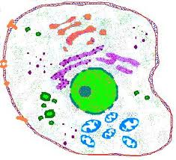
Week 4 - November 21 – November 25
MONDAY - Chapter 7.1 reading guide due at the beginning of hour; Lecture on plasma membrane structure and function.

TUESDAY - Half-day; PM classes only

WEDNESDAY: NO SCHOOL: THANKSGIVING HOLIDAY
THURSDAY: NO SCHOOL: THANKSGIVING HOLIDAY
FRIDAY - NO SCHOOL: THANKSGIVING HOLIDAY
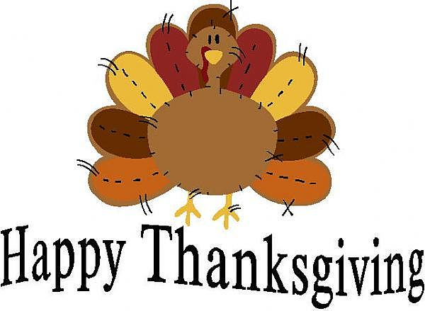
*******************************************************************************************
Week 5 – November 28 – December 2

MONDAY - Cell modeling: Create a poster of a bacterial, plant, or animal cell, with one 3-D functional organelle, and present organelle to class.
TUESDAY - Complete cell modeling activity

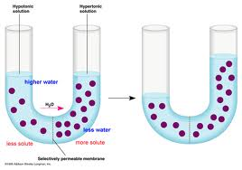
WEDNESDAY - Reading guide 7.2, 7.3, 36.2 due at the beginning of the hour; Lecture Cellular Transport and Water Potential; Hand out AP Investigative Lab: Osmosis and Diffusion; pre-lab questions due Thursday, December 1
THURSDAY - AP Investigative Lab: Osmosis and Diffusion Procedure 1
FRIDAY - Continue Osmosis and Diffusion Lab: Procedure 2

Week 6 - December 5 – December 9
MONDAY – Complete Osmosis and Diffusion Lab. Lab results will be presented as mini-posters. See my website under lab tab for instructions on how to do mini-posters. Mini-posters will be due on Monday, December 12
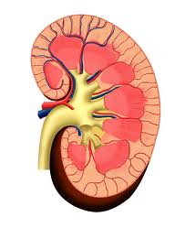
TUESDAY - How do they do that? Cells to higher animals Chapter 44 reading guide due at the beginning of the hour. Lecture: Osmoregulation
WEDNESDAY - Chapter 11 reading guide due at the beginning of hour. Lecture: Cell communication.
THURSDAY - Chapter 48 reading guide due at beginning of hour. Lecture: Neurons, synapses, and signaling
FRIDAY - Chapter 45 reading guide due at beginning of hour. Lecture: Cell signaling in the endocrine system
*********************************************************************************************
Week 7 - December 11 – December 16
MONDAY - Cell unit review day
TUESDAY - CELL UNIT TEST (CHAPTERS 6,7,11,44,45,48) 15-20 MULTIPLE CHOICE QUESTIONS, 2 GRID-IN OR PROBLEM SOLVING, 2 SHORT ANSWER, AND 1 LONG FREE-RESPONSE QUESTION.

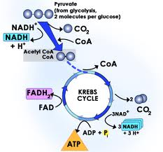
WEDNESDAY - Chapter 8.1, 8.2, 8.3 reading guides due at beginning of hour; Lecture: Introduction to metabolism.
THURSDAY - Chapter 9.1, 9.2, 9.3 reading guidesr; Lecture: Glycolysis and the Kreb’s Cycle (completed Chapter 9 reading guide may be turned in on Wednesday.)

FRIDAY – Chapter 9.4, 9.5, 9.6 reading guides due at beginning of hour. Lecture: Electron transport, chemiosmosis, and fementation.
*********************************************************************************************
Week 8 – December 19 – December 23
MONDAY - Activity: Modeling Cellular Respiration
TUESDAY - Completion and presentation of Cellular Respiration model. *********************************************************************************************

Christmas Break - December 21 – January 3

Week 9 - January 4 – January 6
WEDNESDAY - Complete Cell Respiration Models presentations; Hand out and explain AP Lab 5: Cell Respiration. Pre-lab questions due Monday, December 16
THURSDAY - AP Lab 5: Cellular Respiration; Lab packet due Friday, January 9
FRIDAY - Chapter 42 reading guide due at beginning of hour; Lecture: how do they do that? Cells to higher animals. Circulation and respiration.

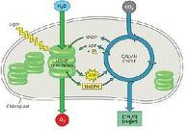

Week 10 - January 9 – January 13

MONDAY - Chapter 10.1 and 10.2 reading guides due at the beginning of the hour (may turn in completed Chapter 10 reading guide on Thursday). Lecture: Structure of the chloroplast and light-dependent reactions of photosynthesis
TUESDAY - Chapter 10.3 and 10.4 reading guide due at beginning of hour; Lecture: Calvin Cycle and C4, CAM photosynthesis
WEDNESDAY - Activity: Practicing Biology – Modeling photosynthesis
THURSDAY - Complete Modeling photosynthesis and presentation of models
FRIDAY - Review day
*********************************************************************************************
Week 11 - January 16– January 20
MONDAY – NO SCHOOL; MARTIN LUTHER KING HOLIDAY
TUESDAY – Review day
WEDNESDAY - MIDTERM EXAMS HALF-DAY
THURSDAY - MIDTERM EXAMS HALF-DAY
FRIDAY - MIDTERM EXAMS HALF-DAY

END OF FIRST SEMESTER

AP Biology Course Outline – 2nd Semester
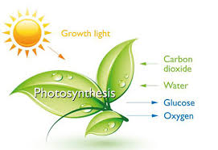
Week 1 - January 19 – January 23
MONDAY - Martin Luther King holiday

TUESDAY - Lecture: Chapter 10.1 and 10.2 Structure of the Chloroplast and light-independent reactions of photosynthesis

WEDNESDAY - Lecture: Chapter 10.3 and 10.4 Calvin Cycle and C4, CAM photosynthesis

THURSDAY - Activity: Practicing Biology - Modeling Photosynthesis

FRIDAY - Complete Modeling Photosynthesis and presentation of models
*********************************************************************************************

Week 2 - January 26 – January 30

MONDAY - AP Lab 5 Photosynthesis Procedure 1; practice floating disk method of measuring photosynthesis; decide on your own investigation and design a procedure.

TUESDAY - Carry out your investigation. A formal lab report on your investigation will be due on Tuesday, February 4

WEDNESDAY - Complete Photosynthesis lab; Learn about Standard Deviation and use of Error Bars

THURSDAY - CELL ENERGY UNIT TEST (CHAPTERS 8.1, 8.2, 9. 10, 42) 20-25 MULTIPLE CHOICE QUESTIONS, 2 GRID-IN OR PROBLEM SOLVING, 2 SHORT ANSWER AND 2 LONG FREE-RESPONSE QUESTIONS

FRIDAY - Half-day, AM only Chapter 12 reading guide due at the beginning of the hour; Lecture on Cell Division in prokaryotes and eukaryotes; Mitosis and the Cell Cycle
*********************************************************************************************

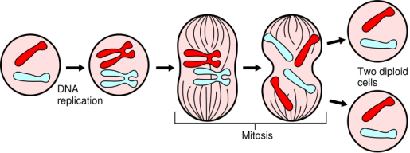
Week 3 - February 2 – February 6

MONDAY - Continue lecture on Chapter 12 - Control of the cell cycle;
TUESDAY - Chapter 13 reading guide due at the beginning of the hour; Lecture on Chapter 13; Meiosis and genetic variation
WEDNESDAY - AP Biology Lab 3 “Mitosis and Meiosis” Part A and Part B
THURSDAY - Complete Lab 3 Part C; Lab Packet due Tuesday, February 10
FRIDAY - - Chapter 14 reading guide due at the beginning of the hour; Lecture Chapter 14 – Principles of Medelian genetics and rules of probability
******************************************************************************
Week 4 - February 9 – February 13
MONDAY - Probability Lab and review of Chi Square
TUESDAY - Complete Chapter 14 lecture; Complex patterns of inheritance; Human Mendelian traits; Lab 3 due at beginning of the hour
WEDNESDAY - Chapter 15 reading guide due at the beginning of the hour; Lecture: Chapter 15 – Chromosomal basis of inheritance

THURSDAY - Complete Chapter 15 lecture; Handout Genetics Practice Problems - work on in class
THURSDAY - Complete Genetics Problems; Go over in class; begin “Dragon Genetics”
FRIDAY - Half-day; PM only; complete “Dragon Genetics” AM classes complete as homework

WINTER BREAK – FEBRUARY 16-FEBRUARY 20

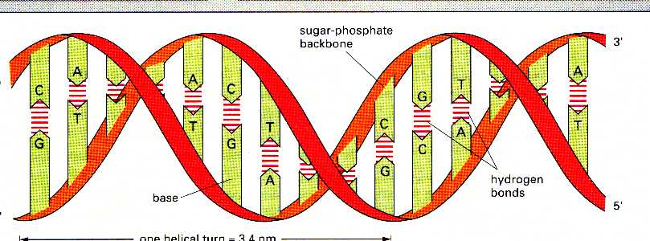
Week 5 - February 23 – February 27
MONDAY - CELL DIVISION AND GENETICS UNIT TEST (chapters 12, 13, 14,15) 25-30 multiple choice questions, 2 grid-ins; 2 short essays, and two long free-response questions.

TUESDAY - Chapter 16 reading guide due at the beginning of the hour; Lecture: History and structure of DNA; DNA replication and its relationship to cancer
WEDNESDAY - “Extraction of Strawberry DNA” Begin Chapter 17 lecture: Transcription and Translation
THURSDAY - Chapter 17 reading guide due at beginning of the hour (Begin with question 11; Continue lecture on Transcription and Translation
FRIDAY - - Chapter 18 reading guide due at the beginning of the hour; Lecture: Regulation of Gene Expression

Week 6 - March 2 – March 6
MONDAY - Complete Lecture on Chapter 18 - Regulation of Gene Expression
TUESDAY - ACT TESTING
WEDNESDAY - - Chapter 19 reading guide due at the beginning of the hour; Chapter 19 lecture: Viruses;
THURSDAY - Chapter 20 reading guide due at the beginning of the hour; Lecture on DNA technology
FRIDAY - Complete Chapter 20 lecture: DNA techonogy; Lab Bench quiz 6 due Monday

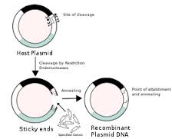
Week 7 - March 9 – March 13
MONDAY - Recombinant DNA lab simulation
TUESDAY - AP Biology Lab 6A: “Molecular Genetics – Transformatiion” setup

WEDNESDAY - Complete “Transformation Lab” Lab Packet due Monday, March 16

THURSDAY - Flexible Catch-up day / Half-day AM classes only – Parent Teacher Conferences

FRIDAY - Preparation for Lab 6B - Molecular Genetics “Gel Electrophoresis and Restriction Fragment Mapping”

SATURDAY LAB - “GEL ELECTROPHORESIS”
TIME TO BE DETERMINED

Week 8 - March 16 – March 20

MONDAY - Review of Molecular Genetics

TUESDAY - MOLECULAR GENETICS UNIT TEST (CHAPTERS 16, 17, 18, 19, 20) 25-30 MULTIPLE CHOICE QUESTIONS, 2 GRID-INS, 2 SHORT ESSAY AND 2 LONG FREE-RESPONSE QUESTIONS

WEDNESDAY - - Chapter 35 reading guide due at the beginning of the hour: Lecture on plant structure and growth
THURSDAY - Chapter 36 (Review water potential from 1st semester) reading guide due at beginning of the hour; Lecture on transport in plants and plant nutrition; Lab Bench for AP lab 9 Transpiration due Friday
FRIDAY - AP Biology Lab 9 “Transpiration” Lab Packet due Wednesday, March 25

Week 9 - March 23 – March 27

MONDAY - Chapter 38 reading guide due at the beginning of the hour; Lecture Chapter 38 Angiosperm reproduction
TUESDAY - Chapter 39 reading guide due at the beginning of the hour; Lecture on plant hormones and photoperiod
WEDNESDAY - Complete plant unit
THURSDAY - PLANT UNIT TEST (CHAPTERS 35, 36, 38, 39) 20-25 MULTIPLE CHOICE, 2 GRID-INS, 2 SHORT ESSAY AND 2 LONG FREE-RESPONSE QUESTIONS
FRIDAY - Half-day PM classes only; Flexible catchup day

END OF THRID MARKING PERIOD

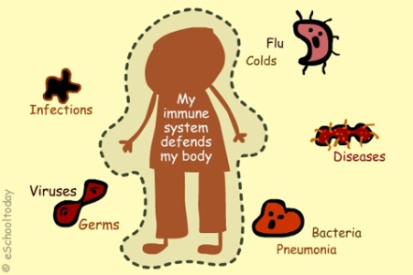
Week 1 - March 30 – April 2
MONDAY - Chapter 43 reading guide due at the beginning of the hour; Lecture on the Immune system
TUESDAY - Complete lecture on Immune System; Pogil activity on immune system
WEDNESDAY - Chapter 47 reading guide due at the beginning of the hour; Lecture on Animal Development
THURSDAY - Half-day AM classes only; Flexible catch-up day
FRIDAY - No school; Spring break begins

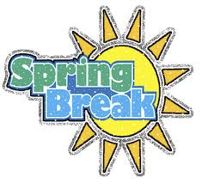
SPRING BREAK - APRIL 6 - APRIL 10
******************************************************************************
Week 2 - April 13 – April 17
MONDAY - Chapter 49 reading guide due at the beginning of the hour; Lecture on nervous systems and the human brain
TUESDAY - Chapter 50 reading guide due at the beginning of the hour; Lecture on selected parts of sensory and motor systems
WEDNESDAY - TEST ON REMAINING VERTEBRATE SYSTEMS (CHAPTERS 43, 47, 49, 50) 20-25 MULTIPLE CHOICE QUESTIONS, 2 GRID-INS, 2 SHORT ESSAYS, AND TWO LONG FREE-RESPONSE QUESTIONS
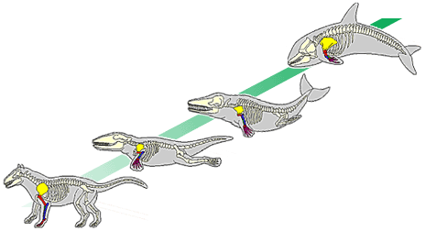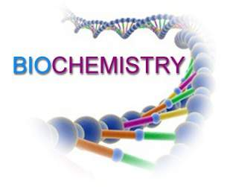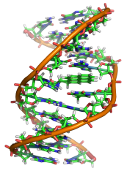
THURSDAY - Begin AP Test Review: Animal Behavior and Lab 1 Fruit Fly Behavior
FRIDAY - AP Test Review: Ecology Unit Review
********************************************************************************************
Week 3 - April 20 – April 24
MONDAY - AP Test Review: Ecology Unit; Dissolved Oxygen Lab
TUESDAY - AP Test Review: Evolution Unit Review
WEDNESDAY - AP Test Review: Evolution: Artificial Selection Lab, Population Labs: Hardy-weinberg and mathematical modeling lab, Phylogeny and BLAST lab
THURSDAY - AP Test Review: Chemistry Unit
FRIDAY - AP Test Review: Chemisty Unit and Enzyme Catalysis lab

Week 4 - April 27 - May 1
MONDAY - AP Test Review: Cell unit
TUESDAY - AP Test Review: Cell unit and Osmosis and Diffusion Lab
WEDNESDAY - AP Test Review: Cell Energy Unit
THURSDAY - AP Test Review: Cell Energy Labs: Photosynthesis and Cellular Respiration
FRIDAY - AP Test Review: Cell cycle and Meiosis

Week 5 - May 4 – May 8
MONDAY - AP Test Review: Mendelian Genetics
TUESDAY - AP Test Review: Molecular Genetics, DNA replication, transcription and translation
WEDNESDAY - AP Test Review: Molecular Genetics Labs: Transformation and Gel Electrophoresis
THURSDAY - AP Test Review: Body Systems
FRIDAY - AP Test Review: Film on Homeostasis; Continue Body Systems

THERE WILL BE A SATURDAY REVIEW SESSION ON MAY 8TH. ALL STUDENTS TAKING THE AP EXAM ARE EXPECTED TO ATTEND. AFTERSCHOOL SESSIONS MAY BE SCHEDULED, DEPENDING ON STUDENT INTEREST.

AP Biology Exam is Monday, May 11

4TH CARDMARKING
Week 1 - April 11 - April 15
MONDAY - Chapter 49 reading guide due at the beginning of the hour: Lecture: Nervous systems
TUESDAY - Chapter 50 reading guide due at the beginning of the hour: Lecture: Sensory systems
WEDNESDAY - Continue Chapter 50 lecture: Motor Mechanisms
THURSDAY - Test on Remaining vertebrates systems : Chapters 43, 46, 47, 49, 50 (Immune system, Animal Reproduction and Development, Nervous systems, and Sensory systems and motor mechanisms)
FRIDAY - AP Test Review Animal Behavior and Lab 12

Week 2 - April 18 - April 22
MONDAY - AP Test Review Ecology Unit
TUESDAY - AP Test Review Ecology Unit and Lab 11 Dissolved Oxygen
WEDNESDAY - AP Test Review Evolution Unit
THURSDAY - AP Test Review Evolution Unit and Lab 8 Population Genetics
FRIDAY - AP Test Review Biodiversity Review

Week 3 - April 25 - April 29
MONDAY - AP Test Review Biodiversity
TUESDAY - AP Test Review Chemistry Unit
WEDNESDAY - AP Test Review Chemistry Unit and Labs 2 Enzyme Catalysis
THURSDAY - AP Test Review Cell Unit
FRIDAY - AP Test Review Cell Unit and Lab 1 Diffusion and Osmosis

Week 4 - May 1 – May 5
MONDAY - AP Test Review Cell Energy Unit
TUESDAY - AP Test Review Cell Energy Unit and Labs 4 and 5 Photosynthesis and Cell Respiration
WEDNESDAY - AP Test Review Body Systems
THURSDAY - AP Test Review Body Systems and Homeostasis
FRIDAY - AP Test Review DNA Labs 6 and 7 Mendelian and Molecular Genetics

In addition to class review, there will be after school review session during the week of April 25 – April 29

AP Biology Exam is Monday, May 9

